AHU Anomaly - Analysis Report

The AHU anomaly detection function **detects hard and soft faults related to air handling units (AHUs).** This function can help identify potential causes for anomalous AHU operations which may cause energy use inefficiencies. The visuals are intended to aid understanding of the detected faults. These depict supply air temperature, and the coolest/warmest/average return air temperatures as a function of outdoor air temperature, and damper and valve actuator positions as a function of outdoor air temperature. Additionaly, a number of diagrams are generated which depict damper and valve actuator positions and temperature readings at characteristic AHU operational periods. More information is available at the respective sections.

# Visuals - Split-range controller

A set of two charts are generated for each AHU inputted. The first (top) plots supply air temperature, and the coolest/warmest/average return air temperatures as a function of outdoor air temperature. For reference, the "ideal" supply air temperature is depicted.  
  
The second (bottom) chart is a Split-range controller diagram, which plots the outdoor air damper position (OA), heating coil valve position (HC), cooling coil valve position (CC) and average fraction of active perimeter heaters (RAD) with respect to outdoor air temperature. The four underlaying color zones represent the four distinct operating mode: Heating (red zone), economizer (yellow zone), economizer with cooling (grey zone), and cooling (blue zone). As an example, the below Split-range controller diagram is representative of normal AHU operations.

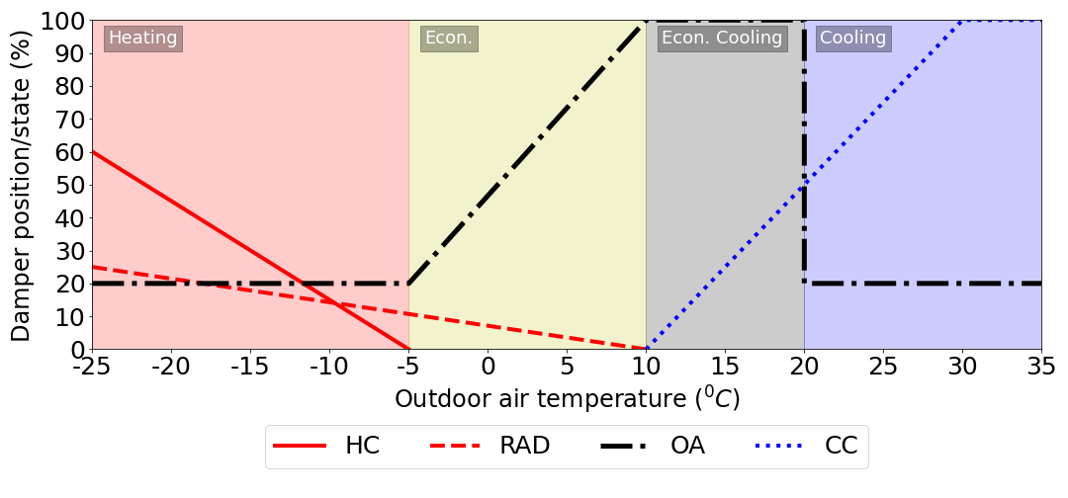

## AHU: ahu1.csv



## AHU: ahu2.csv



# Visuals - AHU operating periods

A set of four to six visuals per AHU are generated which depict characteristic operating periods of the AHU and the average damper and valve positions and temperatures at those periods. The fraction of time of operation is the percentage of the total time of the AHU's operation which exhibit the displayed damper/valve positions and temperatures.

## AHU: ahu1.csv

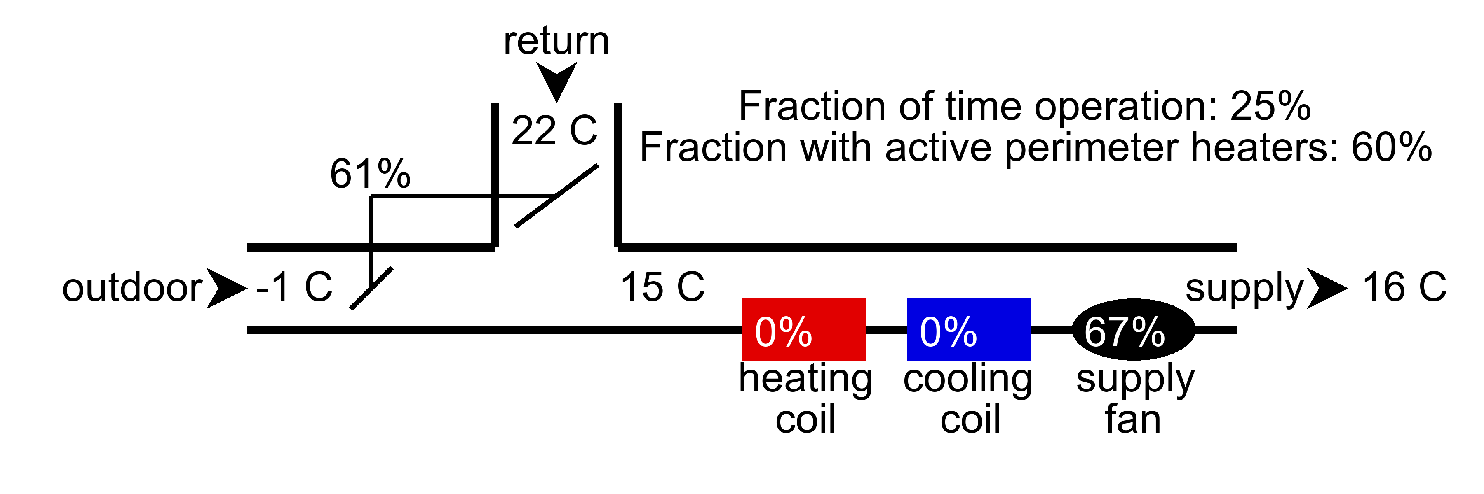

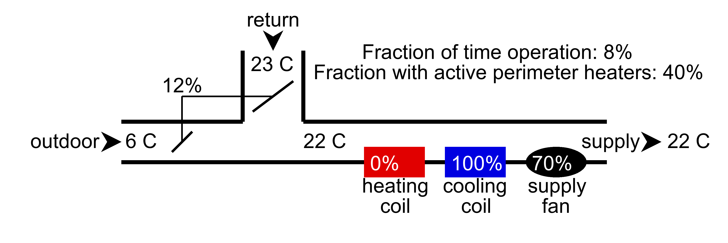

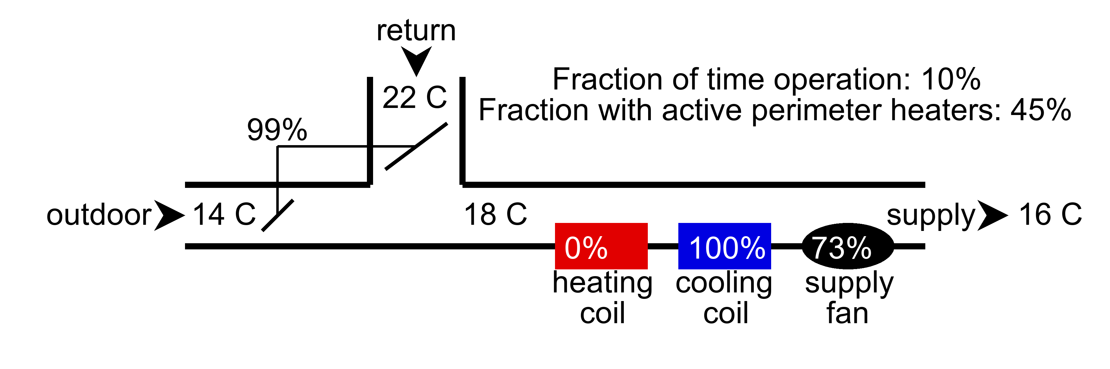

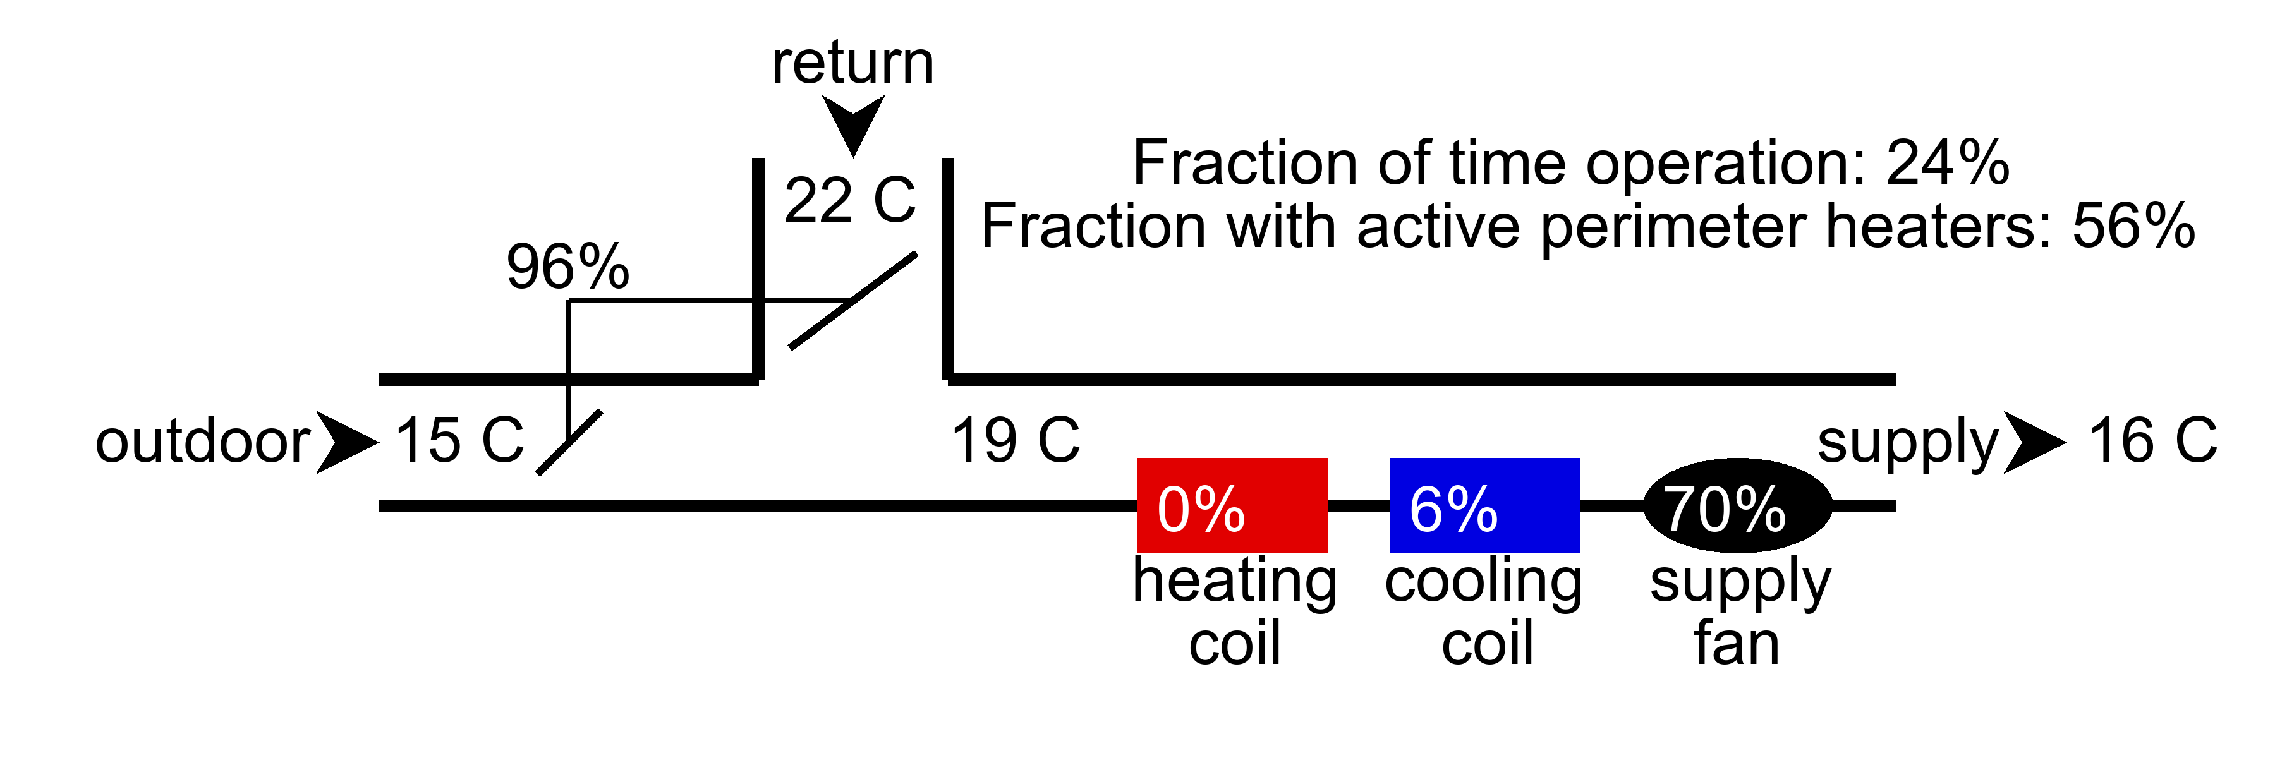

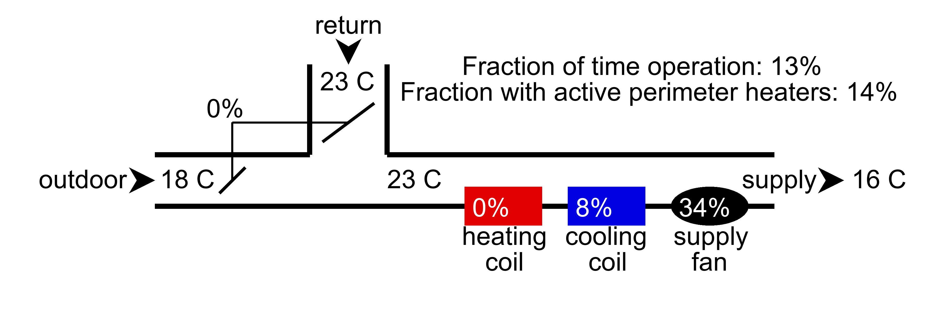

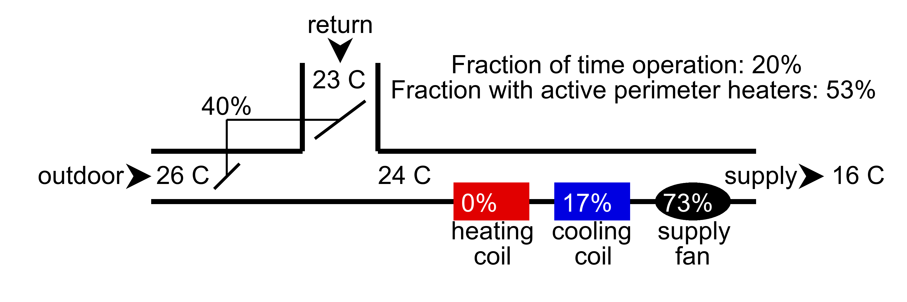

## AHU: ahu2.csv

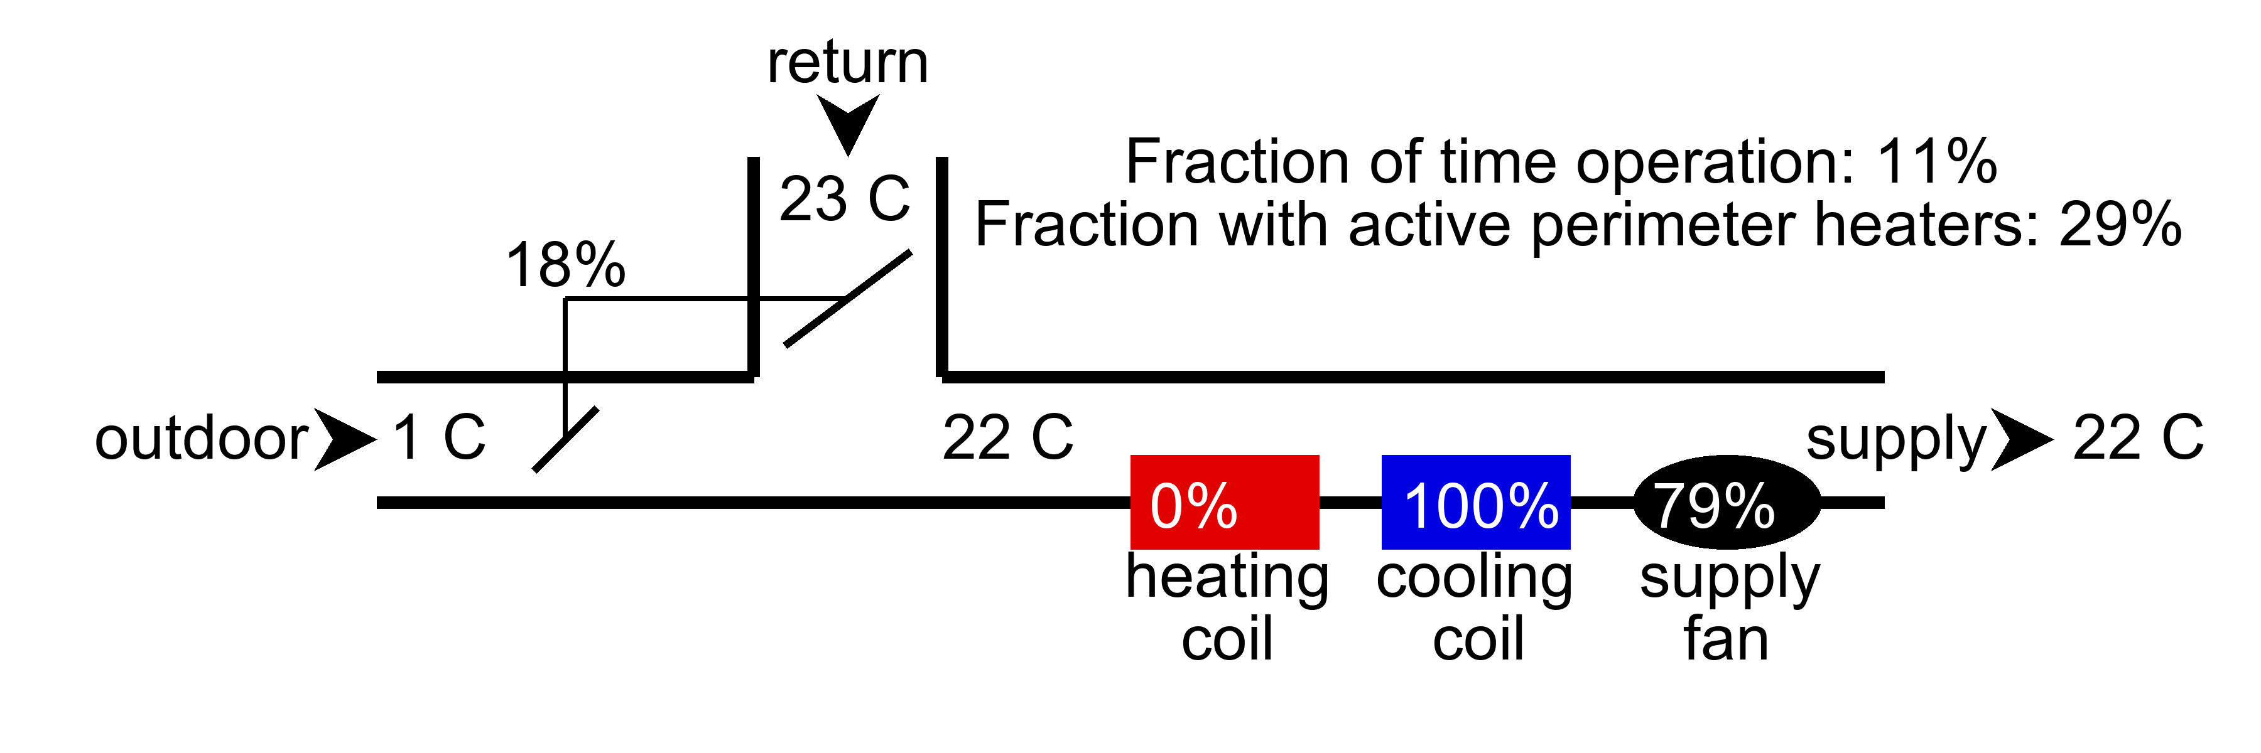

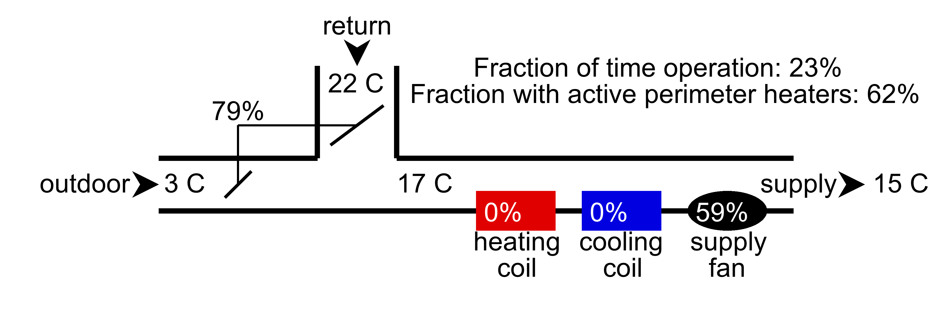

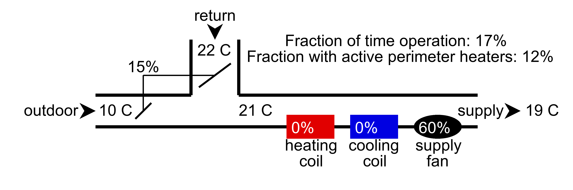

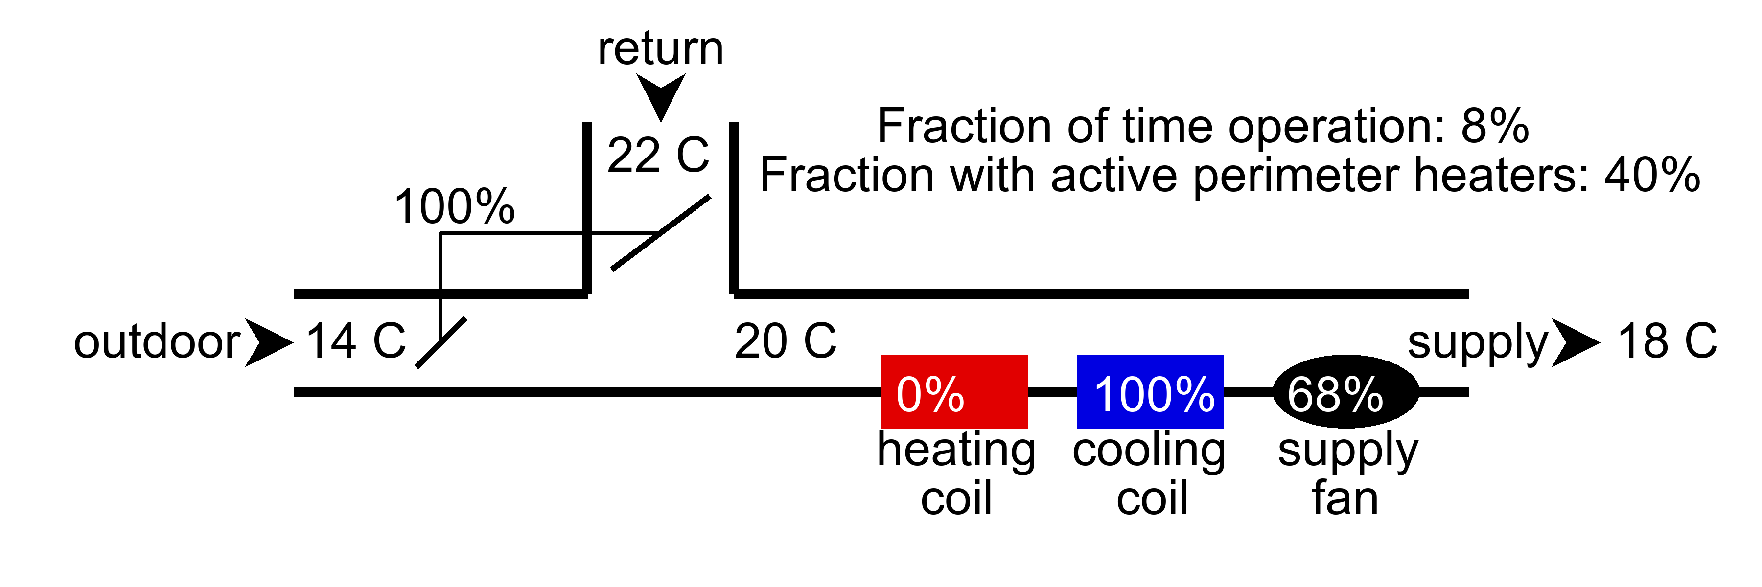

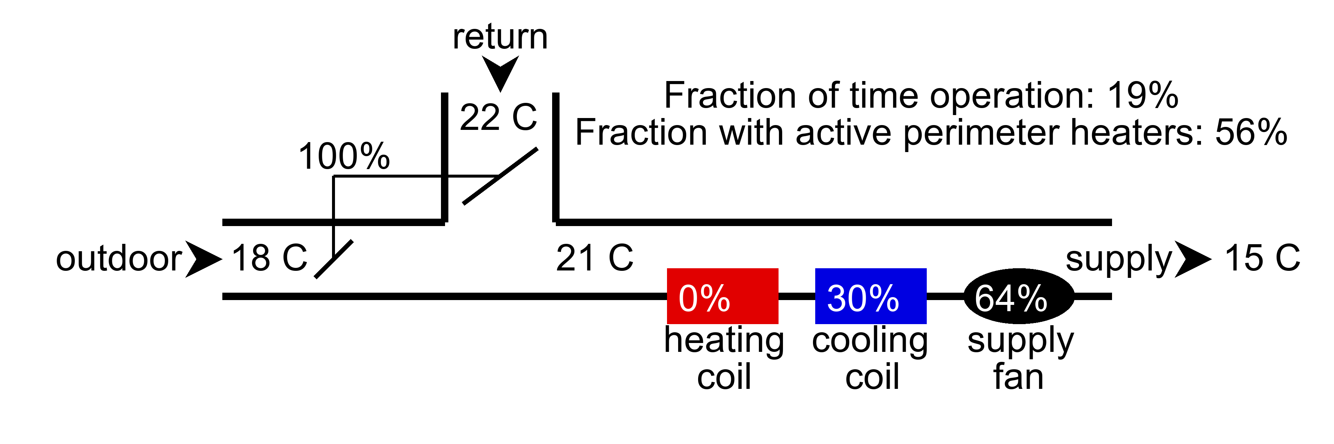

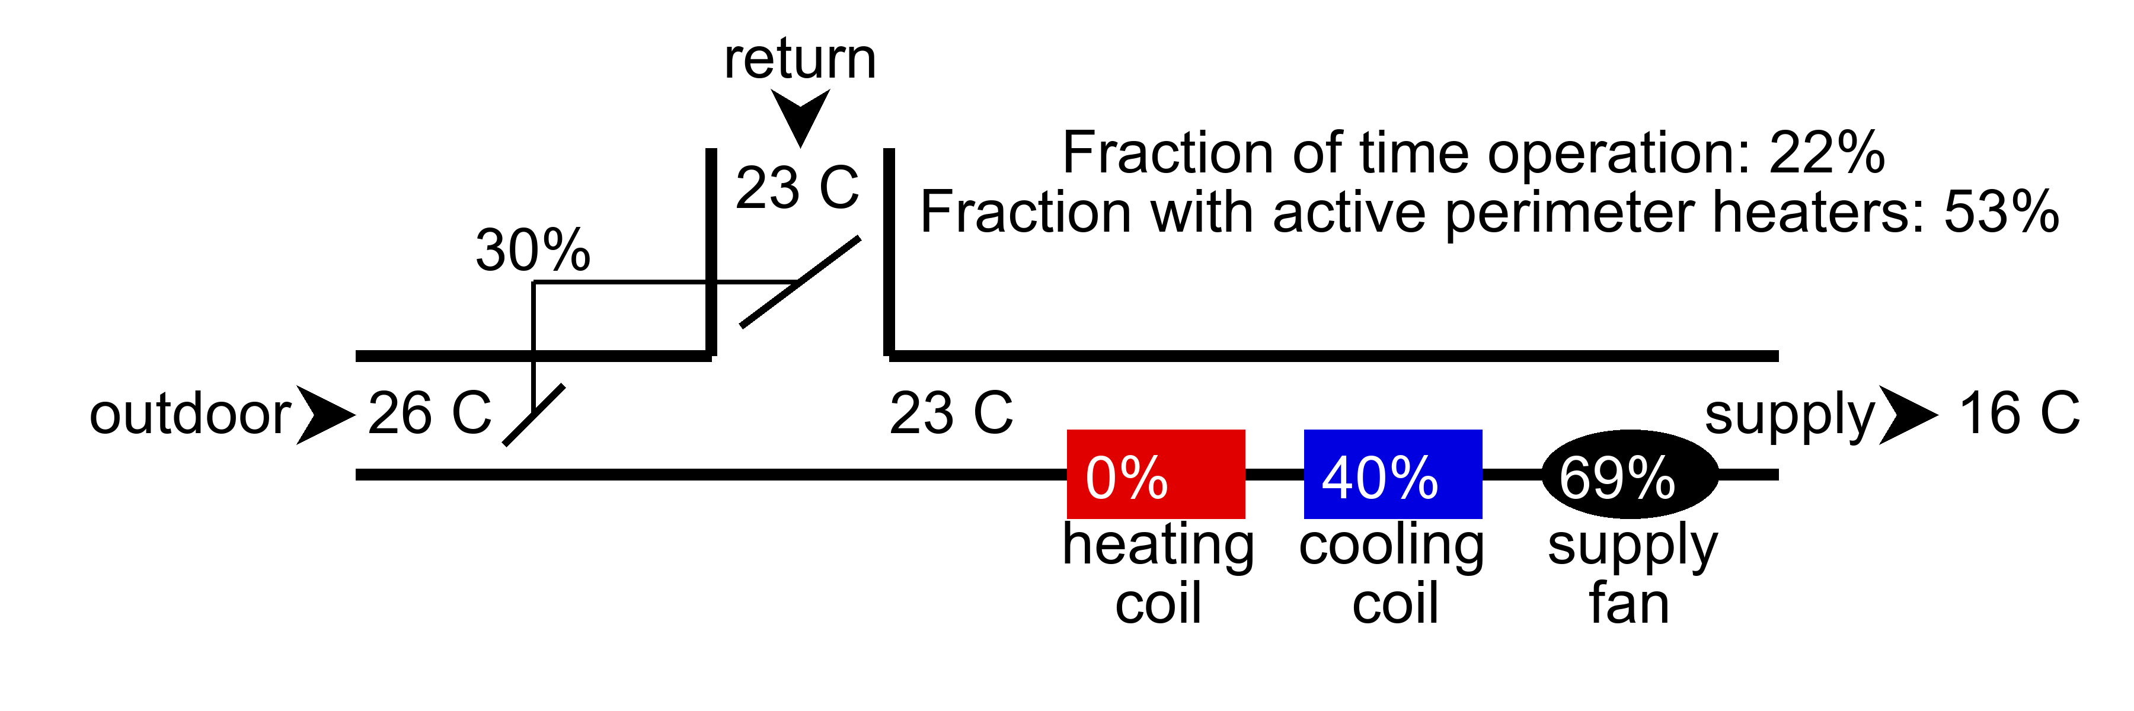

# Key performance indicators - AHU faults

The following table lists the hard and soft faults identified by the function. The AHU health index is also provided for each AHU which is 100% if no faults are detected and 0% if all six faults are detected.

|  |  |  |  |  |  |  |  |
| --- | --- | --- | --- | --- | --- | --- | --- |
| AHU | AHU Health Index (%) | Cooling coil | Economizer | Heating Coil | Outdoor Air Damper | Schedule | Supply air temperature |
| ahu1.csv | 50% | Normal | Normal | Stuck | Normal | Check mode of operation logic | Check supply air temperature reset logic |
| ahu2.csv | 33% | Normal | Normal | Stuck | Low outdoor air | Check mode of operation logic | Check supply air temperature reset logic |